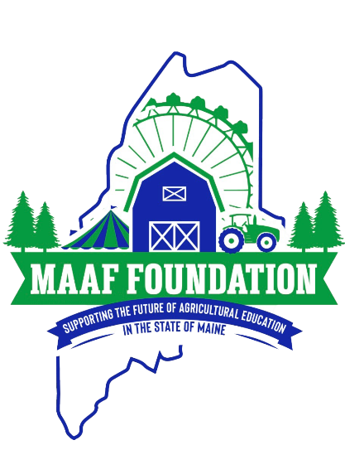

**MAAF FOUNDATION SCHOLARSHIP**

**APPLICATION FORM**

The MAAF Foundation will be granting at least two (2) $2000 scholarships to graduating High School Seniors. Our purpose and intention are to give recognition and financial assistance to the recipient in their quest in pursuing a post-secondary education in an Agricultural Related Field.

The MAAF Foundation Scholarship Committee will choose the recipients of these scholarships. The committee will make a decision based on the information provided from this application. The recipients will be announced in June. Monetary awards will be given following successful completion of the first semester of post-secondary education and proof of enrollment in a second semester.

**PLEASE provide the Committee with the following information:**

1. Briefly describe your post-secondary education plans and career aspirations
2. Briefly describe your connection or affiliation with Maine Agricultural Fairs
3. List school, community and work activities.
4. Include a letter of recommendation from a mentor or educator in your life (not related to you).

**PLEASE use this Application as your Cover Page.**

**Applicants Name: _______________________________________________________________**

**Address:_______________________________________________________________________**

**Telephone #:___________________________  Email address:___________________________**

**High School:___________________________________________________________________**

**Date of Graduation:_____________________________________________________________**

**Please Mail by April 15 to:**

**MAAF Foundation Scholarship Committee**

**c/o Hope Ricker**

**8 Caston Road**

**Pittston, ME. 04345**

**or Email: info@maaffound.com**